**Approval Flow**

**Approval OOTB Flow in SP2010**

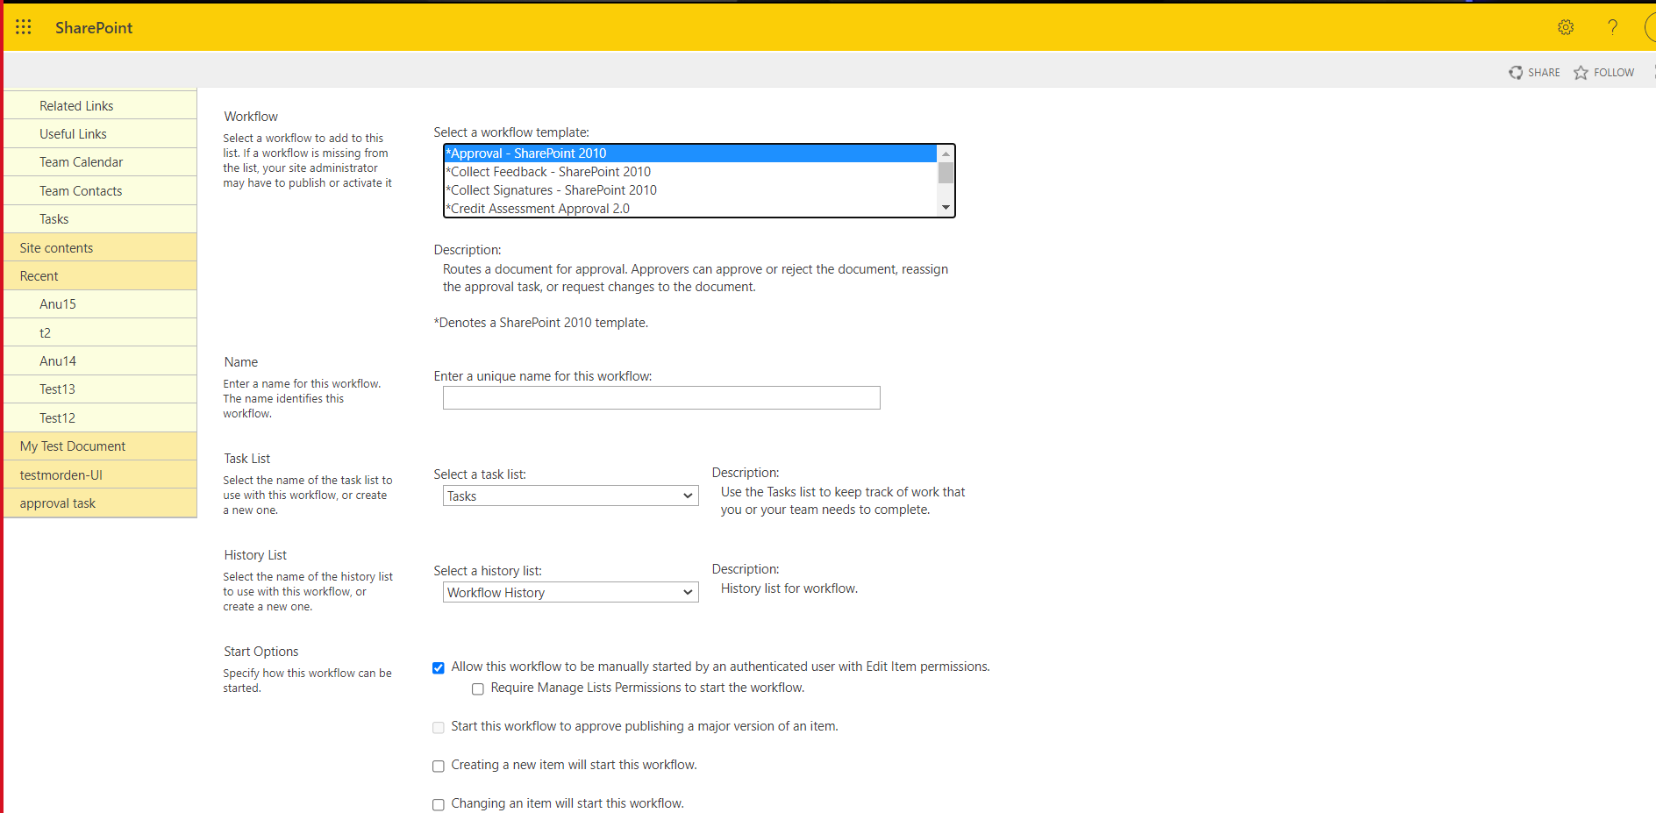

1. Select the Approval template
2. Provide the Unique name for the approval workflow
3. Select the Trigger
4. Click next

**Approval OOTB Flow in SP2010**

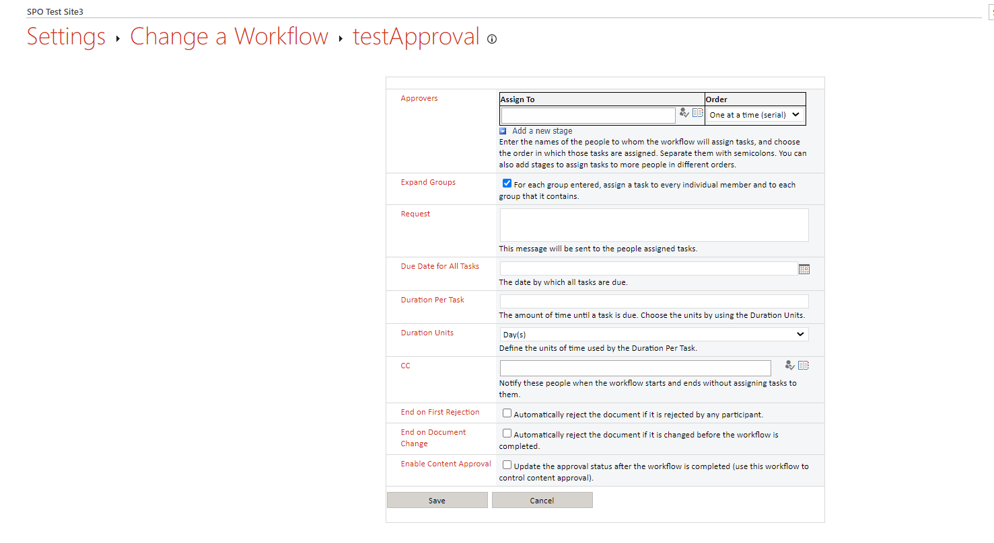

Fields present in Approval Form

**Approvers**:

**Assign-To**: We can add the people who are required to be part of this approval WF

**Order**: It can be Serial (request will be sent sequentially) or Parallel (request will be sent to everyone at a time)

**Add a new Stage:** We can add stages as per the sequence, we want to send the approval in Hierarchy mode

**Expand Group** :

If we add groups, then we can assign task to individual members present inside the group

**Request Field**:

It’s a description box, where we can write the request description for which the approval task will be assigned to that particular person

**Due Date for all tasks:**

It is the timeline for entire workflow. After this timeline, the workflow will be terminated

**Due Date for individual task:**

It is the timeline given for individual task that is assigned to **per user**

**Duration Units:**

The Timeline Unit

**CC:**

We can add a person here, who can monitor the activities going on, but will not have the permission to act on any tasks

**End on First Rejection:**

If the user chooses this option, before creating the workflow, then, in any point of time the workflow is running, if any one person rejects the task, then the workflow will be terminated there itself

**End on Document Change:**

When the workflow is in running condition, if anybody tries to modify the document in between, the task will get terminated

**Enable Content Approval:**

For people having read-only permissions , if any list item is added , it will ask for an approval , and prior to that response only , it will be visible or not be visible for them.

**Approval Template in Power Automate**

**URL:** <https://emea.flow.microsoft.com/manage/environments/Default-c7ba1ffa-0912-4ec7-be94-7cfcb8a19dd6/flows>

**Credentials** : StAn MaRsh

**WF Name:** OOTB_Approval_List_withRemainder

**WF Name:** OOTB_Approval_Createfile_withRemainder

**OOTB_Approval_List_withRemainder**

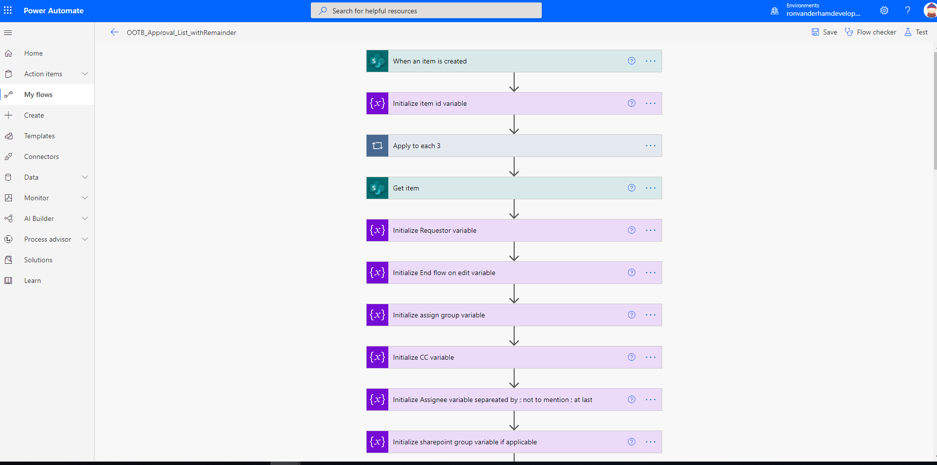

Configurations to be done while using this template

1. **When an item is created**:

Provide the SITE URL

Provide the List Name

1. **Get Item**

Provide the SITE URL

Provide the List Name

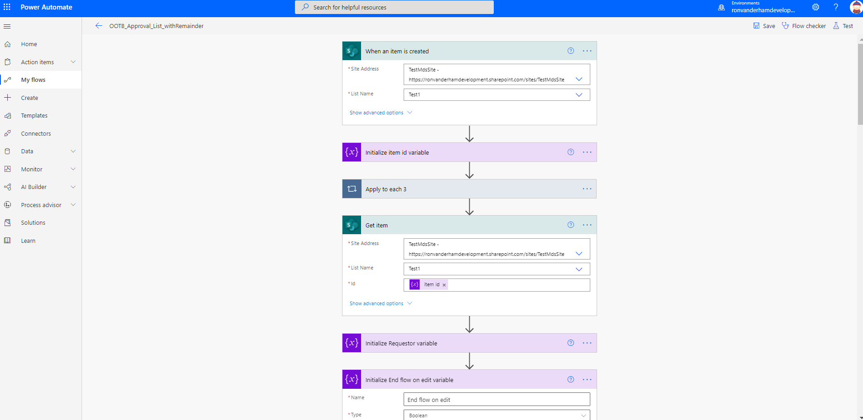

1. **Approvers Data**
2. If the Approver is User
3. If the Approver is O365 Group
4. If the Approver is Sharepoint Group
5. User

Initialize assign group variable to False

Initialize assignee variable with User mail address separated by ;

(Note: should not mention ; after giving the last Approver mail id)

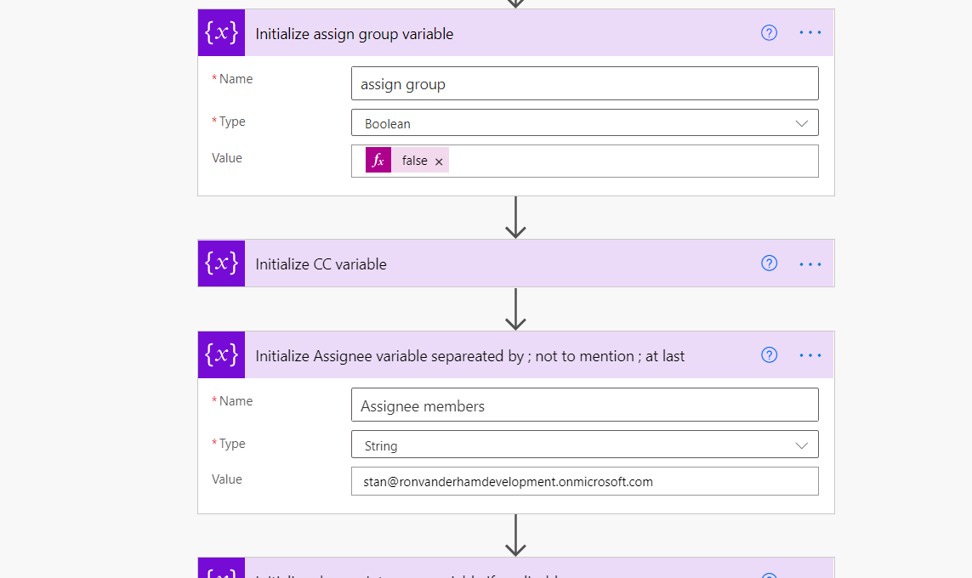

1. O365 Group

Initialize assign group variable to True

Initialize assignee variable with Group mail address

3)SharePoint Group

Initialize assign group variable to True

Initialize SharePoint group variable with Group name

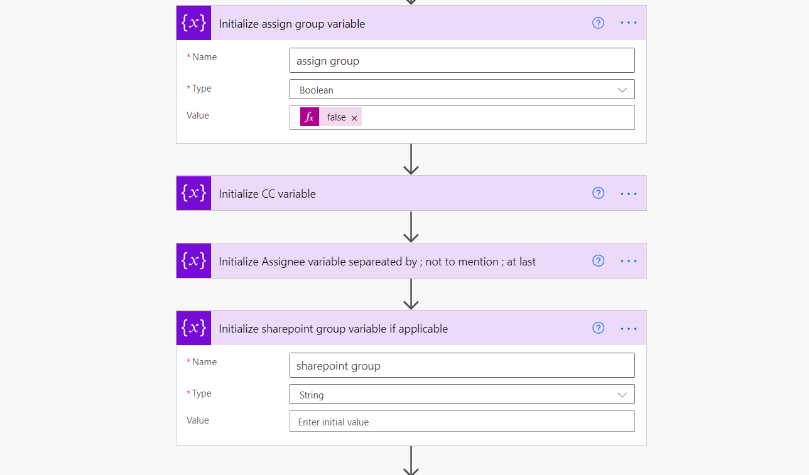

1. **CC**

Mention cc user if applicable in CC variable

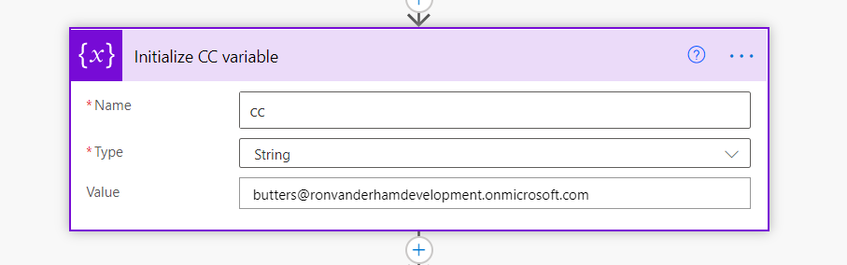

1. **Order**

Initialize order in Order variable

For Parallel order mention All at once (Parallel)

For Serial order mention serial

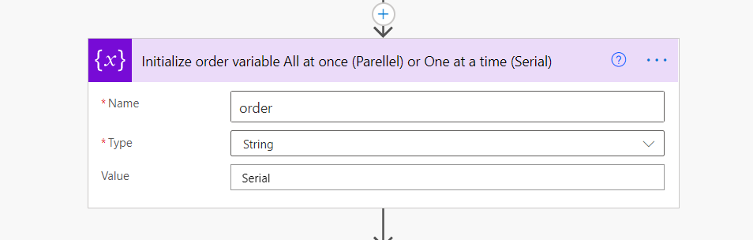

1. **Due Date**

Initialize due date in Due date variable in yyyy-MM-dd format

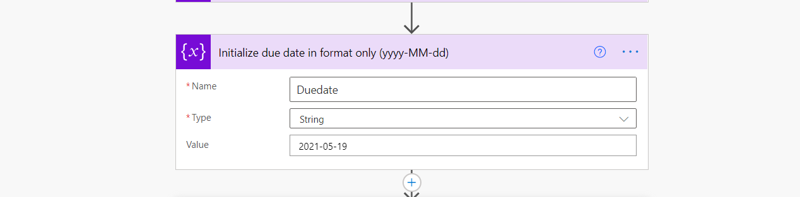

1. **Duration per task**

Initialize Duration per task

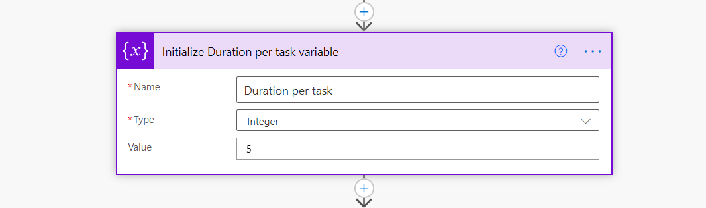

1. **End of first Rejection**

Initialize End of rejection is “True” if Applicable

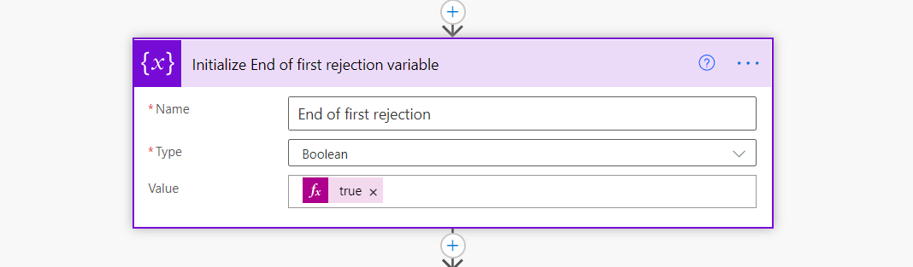

1. **End flow on Edit**

Initialize End flow on edit is “True” if Applicable

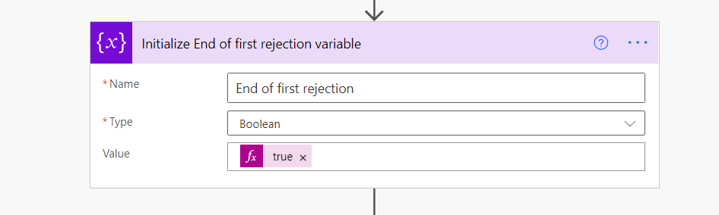

If true update item with 3 field

Environment Id – workflow()?['tags']['environmentName']

Flow Id – workflow()?['name']

Instance Id – workflow()?['run']['name']

CancelFlow – “No”

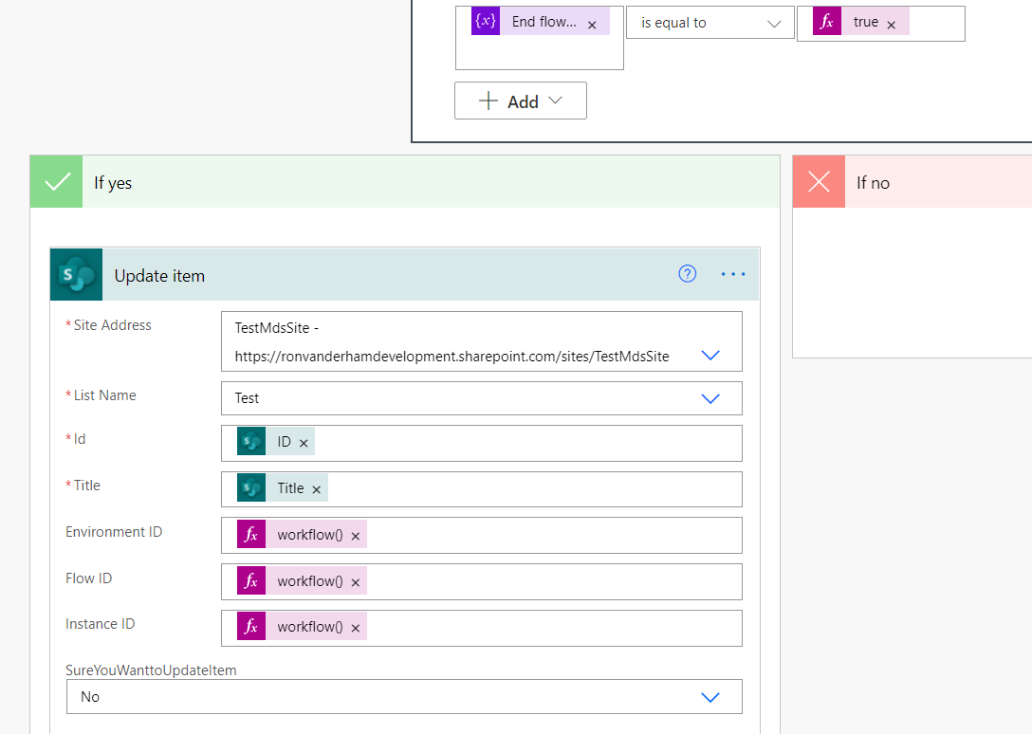

1. **Enable content Approval**

Initialize content Approval to True if applicable

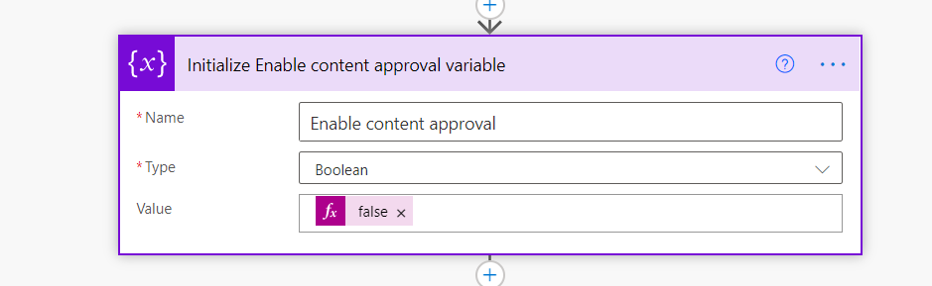

If True:

for Approve Outcome Set Content Approval Status – Approve

for Reject Outcome Set Content Approval Status – Reject

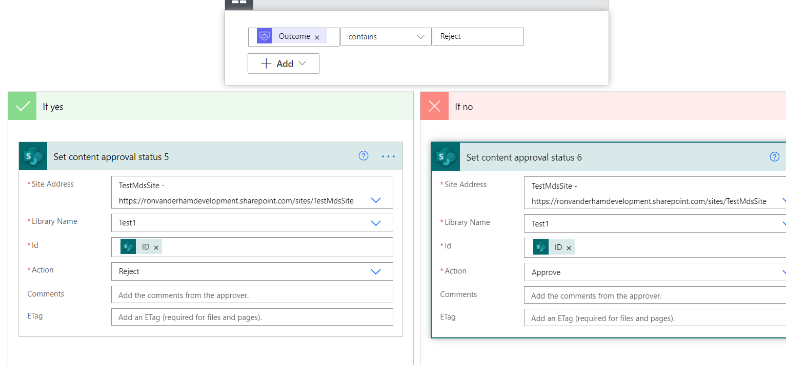

1. **Remainder List**

Create Remainder List with following columns mentioned in below screen shot

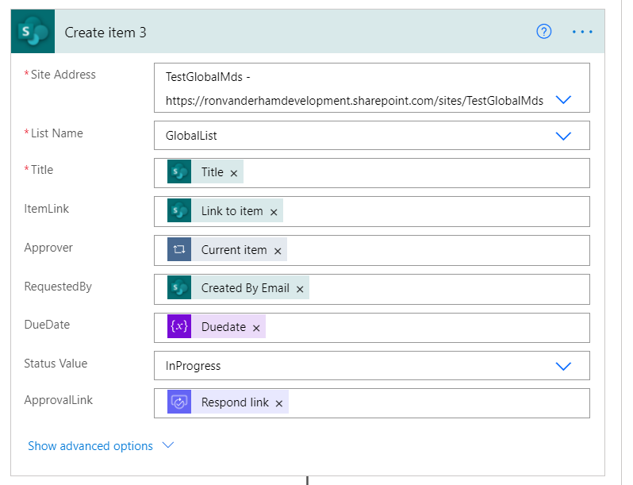

Marking Status to Complete for above created item after outcome received

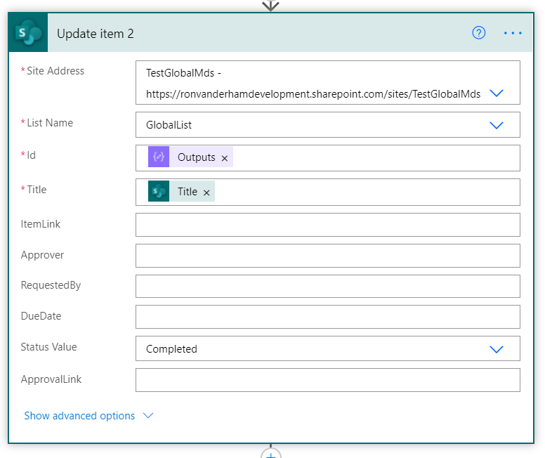

**Cancel Flow Configuration**

1. **When an item or file is modified**:

Provide the SITE URL

Provide the Library Name

Trigger condition - @and(not(empty(triggerBody()?['Environment_x0020_ID'])),equals(triggerBody()?['CancelFlow'],true))

1. **Get file file properties**

Provide the SITE URL

Provide the Library Name

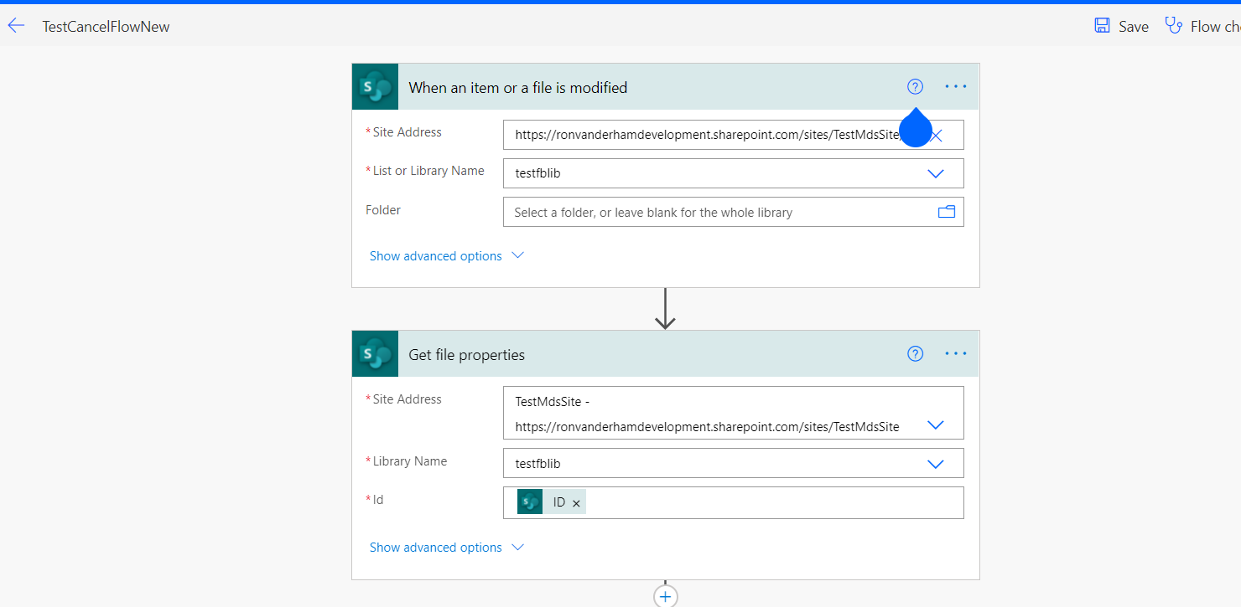

1. **Workflow status action**

Provide Environment ID, Flow ID and Instance ID from output of get file properties

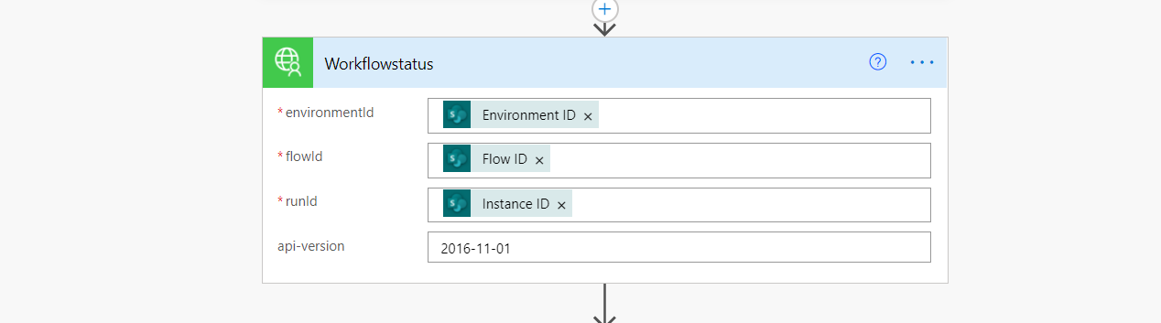

1. **Cancel Flow action**

Provide Environment ID, Flow ID and Instance ID from output of get file properties

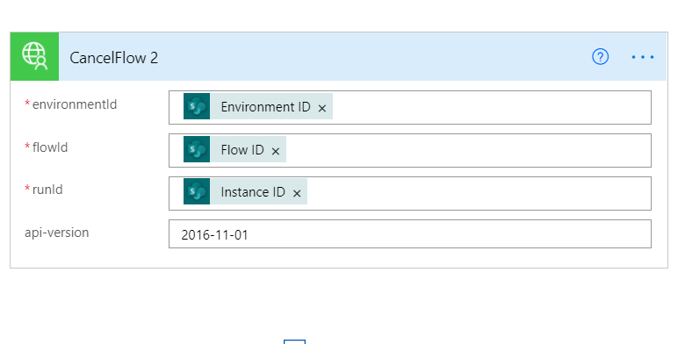

**Remainder Flow Configuration**

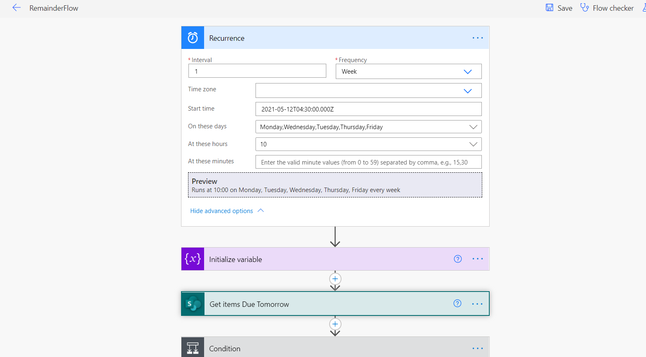

1. **Get items Due tomorrow**

Provide Site URL and List Name

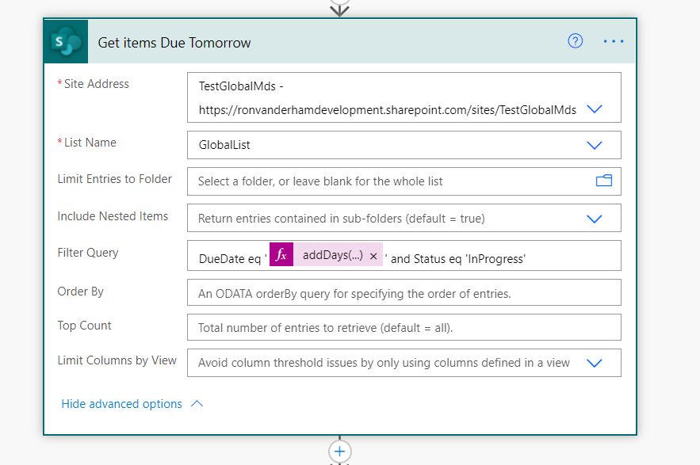

1. **Get items Due today**

Provide Site URL and List Name

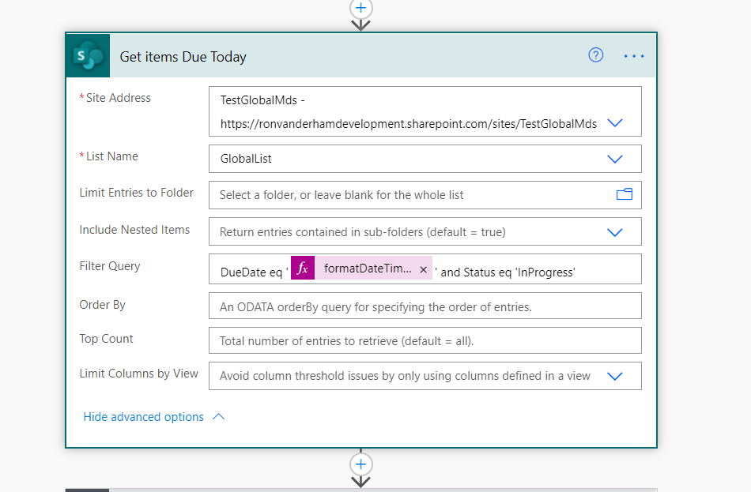

1. **Get items overdue**

Provide Site URL and List Name

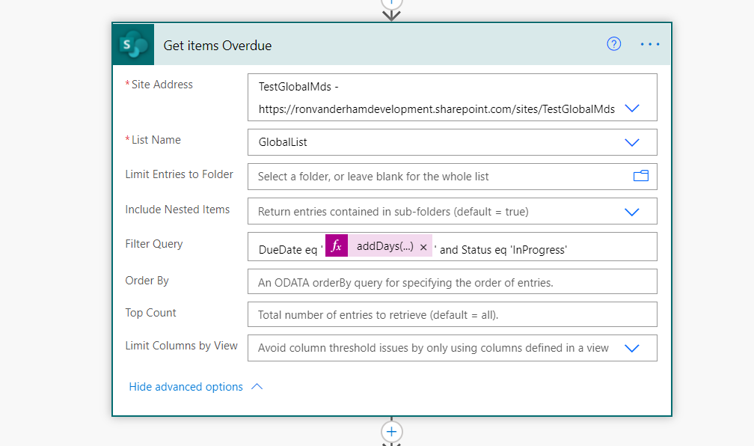

Below are the templates







**Note:**

Configuration for other templates are same but only trigger and get item or get file differ in each template based on list or library

**Custom Connectors used in flow**

1. Get O365 group members
2. Cancel Flow instance

**Get Group Connector**

Two Actions

1. Get Group Details
2. Get members

Get Group Details:

O365 mail address is provided as input and this action returns group id of O365 group.

Get Members:

From above group id this action returns members of group

**Cancel Flow**

Two Actions

1. Get flow status
2. Cancel flow

Get Flow status:

Env ID, Flow ID, Instance ID are supplied as input to this action and this action return status of the flow.

Cancel flow

This action cancels the InProgress status flow by suppling the Env ID, Flow ID and Instance ID as input

**Custom Connector JSON**

**O365 Group Connector**



**Cancel Flow Connector**

